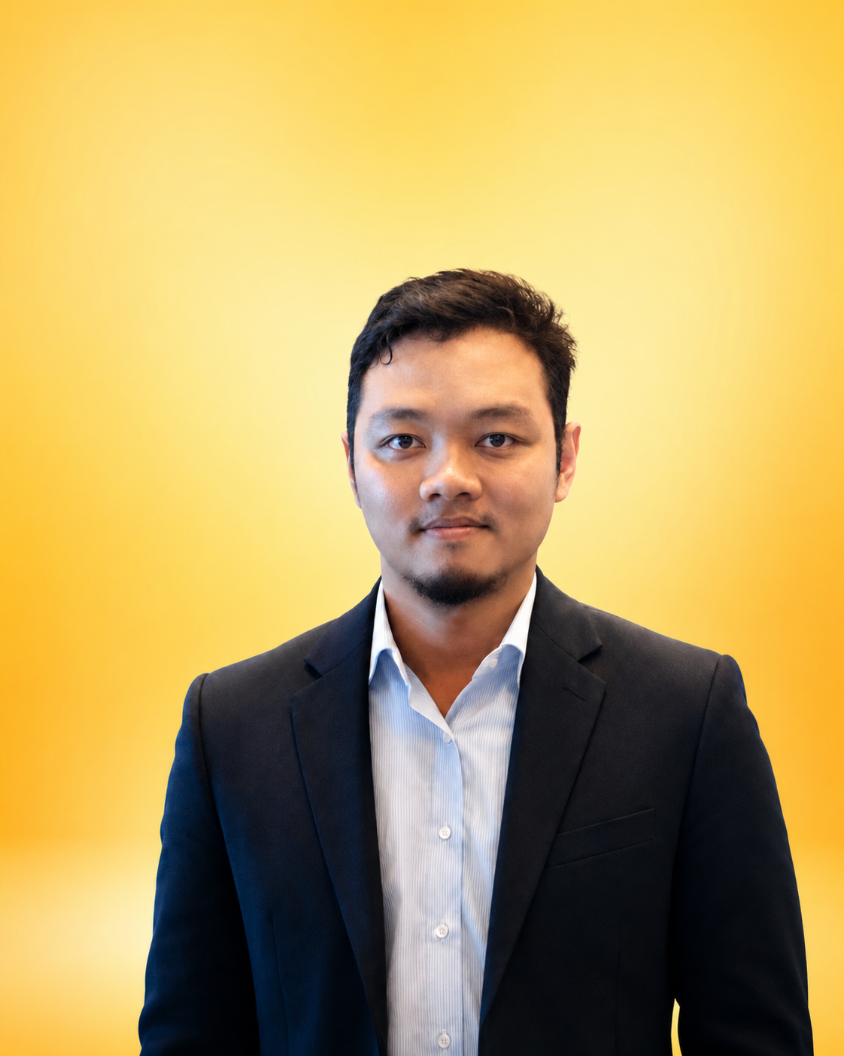  CONTACT  LOCATION Greater Jakarta Area, Indonesia  LINKEDIN linkedin.com/in/aditya-wardanur-23a439a2  CORE EXPERTISE  Software Engineering  Business Application Development  Data Analytics & Dashboards  Machine Learning  AI / LLM Applications  System Design & Architecture  Process Automation  TECHNOLOGY  PHP • Laravel • CodeIgniter  JavaScript • AJAX • Bootstrap  MySQL • PostgreSQL  Python • Pandas • scikit-learn  RAG • Ollama • llama.cpp  REST API • DataTables  Git • Linux/Windows tooling  LANGUAGES  Bahasa Indonesia — Native  English — Professional working proficiency | ADITYA  WARDANUR  SOFTWARE ENGINEER | DATA ANALYST | MACHINE LEARNING | AI DEVELOPER  PROFESSIONAL SUMMARY  Software engineer and data practitioner with more than a decade of experience supporting business operations through application development, data analysis, automation, and digital solutions. Strong hands-on background in PHP-based web systems, relational databases, dashboards, and business process applications, with an expanding focus on machine learning, predictive analytics, and practical AI/LLM implementation. Combines software engineering discipline with an interest in turning operational and customer data into scalable systems, measurable insights, and smarter decisions.  PROFESSIONAL EXPERIENCE  PT AGUNG AUTOMALL  Software Programmer | Nov 2014 – Present  - Develop and maintain internal web-based business applications that support sales, customer/prospect management, KPI monitoring, reporting, and operational workflows.  - Build application modules and data-driven dashboards using PHP, Laravel, CodeIgniter, MySQL, JavaScript/AJAX, Bootstrap, and DataTables.  - Translate operational requirements into maintainable systems, reports, and workflow automation that reduce repetitive manual work and improve visibility of business performance.  - Work with sales, customer, and prospect datasets to support segmentation, lead prioritization, performance monitoring, and insight generation.  - Prototype machine-learning use cases for prediction and classification, including prospect-status modeling and data preparation workflows in Python.  - Explore practical AI/LLM solutions using local model tooling, RAG patterns, PostgreSQL-backed retrieval, Ollama, and llama.cpp.  - Contribute to discussions and prototypes around scalable architecture, API integration, monolith modernization, and microservice-oriented system design.  CURRENT PROFESSIONAL FOCUS  - Building data capabilities as a strategic foundation for machine learning and AI adoption.  - Automating repetitive analysis, finding patterns in operational data, and converting data into actionable business knowledge.  - Designing practical AI prototypes that can be integrated with existing enterprise and sales workflows.

EDUCATION  UNIVERSITAS KUNINGAN  Bachelor's Degree — Information Systems  2008 – 2012  Activity: Computer Lab Assistant  UNIVERSITAS BUDI LUHUR  Master's Studies — Computer Science  CERTIFICATION  Strengthening Your Leadership Talent  PPM Manajemen  STRENGTHS  Analytical problem solving  Business–technology translation  Continuous learning  Cross-functional collaboration  Leadership development  Innovation mindset  INTERESTS  Applied AI for industry  Data-driven sales & marketing  Machine learning adoption  Enterprise application modernization  Microservices & scalable systems | SELECTED CAPABILITIES & PROJECT AREAS  BUSINESS APPLICATIONS & ANALYTICS  - Sales and KPI applications covering target, achievement, score calculation, and business performance monitoring.  - Customer and prospect data workflows designed for follow-up visibility, prioritization, segmentation, and decision support.  - Interactive operational dashboards and tabular reporting using server-side data processing, AJAX, and DataTables.  - Database-backed enterprise applications using Laravel/CodeIgniter with MySQL and PostgreSQL.  MACHINE LEARNING & AI  - Supervised-learning experiments for prospect classification and predictive status modeling, including imbalanced-data handling such as SMOTE.  - Local LLM experimentation with Gemma and Qwen-family models through Ollama and llama.cpp environments.  - RAG application concepts combining document ingestion, vector/retrieval workflows, PostgreSQL, and local language models.  - AI use-case exploration focused on automating repetitive data analysis, generating insights, and supporting business decision-making.  ARCHITECTURE & ENGINEERING  - Hands-on experience with monolithic business applications and active exploration of microservice architecture patterns.  - REST API integration, modular backend design, relational data modeling, and maintainable web application architecture.  - Interest in system scalability, service boundaries, data ownership, and platform choices for modern distributed applications.  LEADERSHIP & PROFESSIONAL ENGAGEMENT  - Completed the “Strengthening Your Leadership Talent” credential issued by PPM Manajemen.  - Participated as part of Agung Automall’s programmer team in the company’s technology and digital transformation representation at TOP Digital Awards 2023.  - Shares professional content on practical AI adoption, microservices, and modern web application development.  CAREER DIRECTION  Seeking to deepen the intersection of software engineering, data analytics, machine learning, and AI—building practical systems that improve business execution, customer understanding, and decision quality.

